**School of Computing and Information Technology**

**CSIT 321 Final Year Project (Oct 2020 - March 2021)**

**User Manual**

**Project Topic**: Secure Password Storage

**Topic Code**: CSIT-20-S4-21

**Date**: 20 February 2021

**Group Number**: Easy Vault (FYP-20-S4-10)

|  |  |  |
| --- | --- | --- |
| **Project Group** | FYP-20-S4-10 | |
| **Team Members** | | |
| **Name** | **Student No (UOW)** | **Email** |
| Jay Tan Soon Boon | 6347010 | jsbtan001@mymail.sim.edu.sg |
| Jaryl Quek Wee Yuan | 6342309 | jwyquek001@mymail.sim.edu.sg |
| Koh Kai Xuan | 6346893 | kxkoh004@mymail.sim.edu.sg |
| Lai Sen Hui | 6276799 | shlai002@mymail.sim.edu.sg |
| Lim Zhi Kai Roger | 6573344 | zkrlim001@mymail.sim.edu.sg |
| **Project-In-Charge** | | |
| Mr Tan Kheng Teck | Project Supervisor | khengtecktan@yahoo.com.sg |
| Mr Japit Sionggo | Project Assessor | sjapit@uow.edu.au |

**Installation** **4**

Google Chrome Users 5

Microsoft Edge Users 8

**Setup** **10**

**Registration** **11**

**Login** **13**

**Resend OTP** **15**

**Forget Password** **16**

**Adding Password via Application** **18**

**Editing Password via Application** **20**

**Deleting Password via Application** **22**

**Password Generation** **24**

**Password Autofill** **26**

**Changing of Easy Vault Username** **28**

**Changing of Master Password** **30**

**Deleting Easy Vault Account** **32**

**Logout** **34**

# Installation

Step 1: Go to <https://easyvault.000webhostapp.com/index.html> and click on “Download” to download the application files.

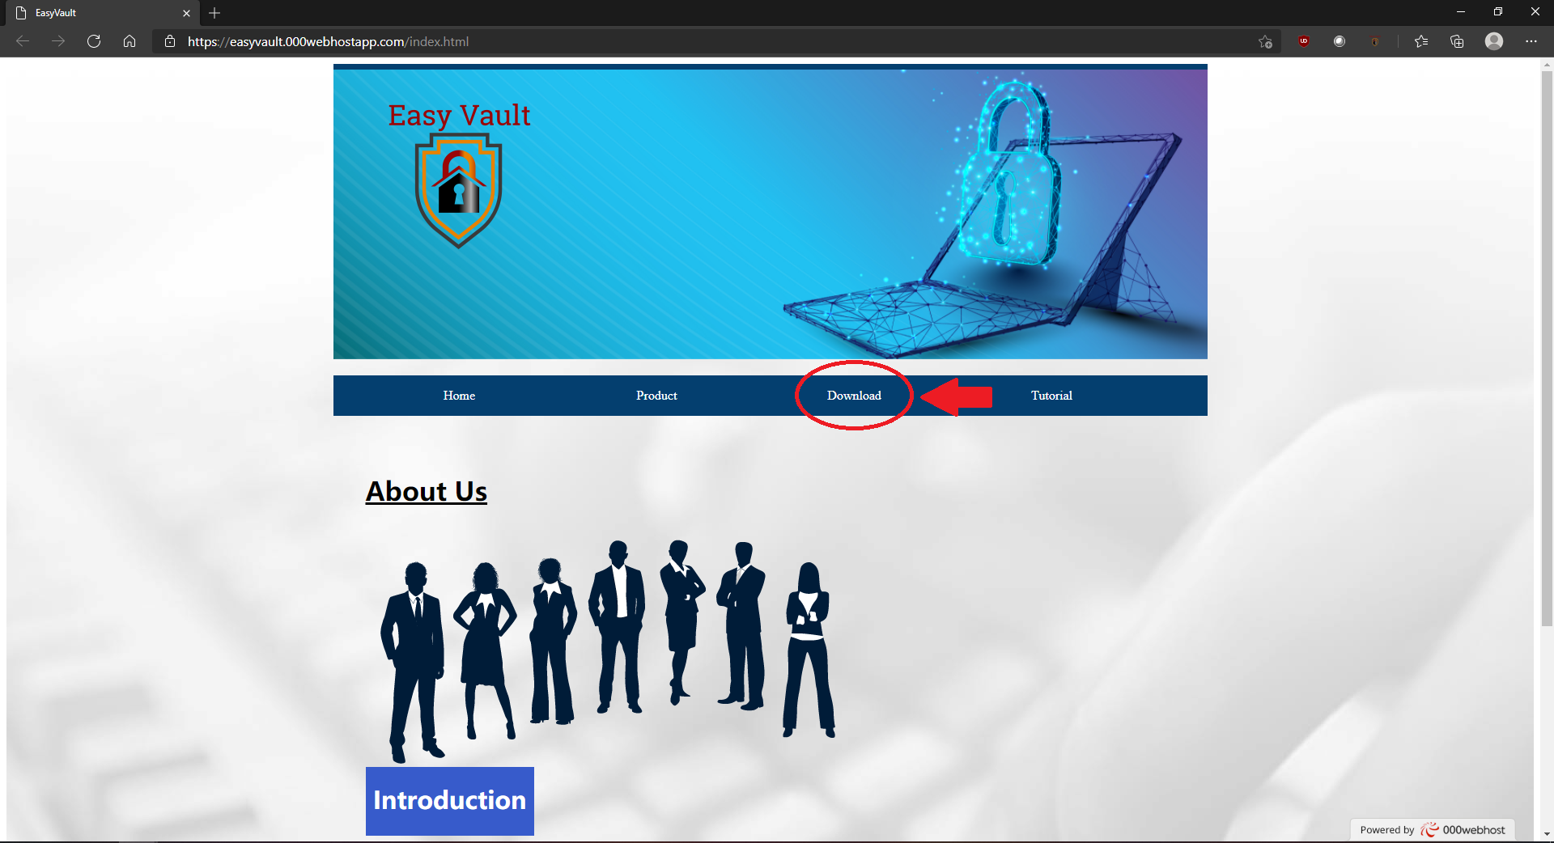

Step 2: Unzip and extract the Zip files to anywhere on your machine.

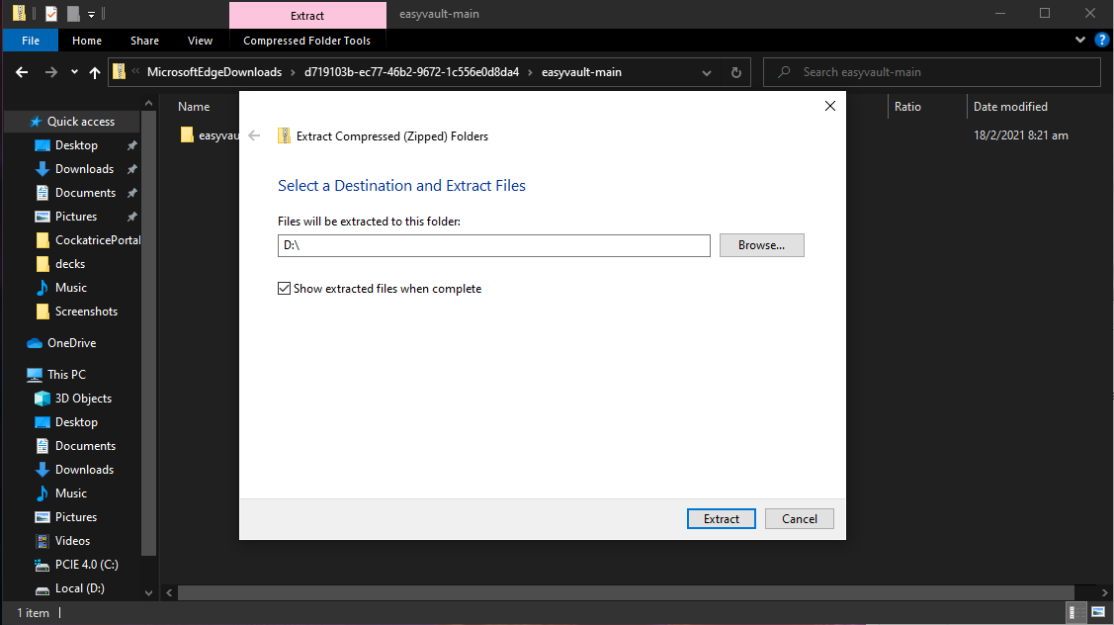

## Google Chrome Users

Step 3: Proceed to chrome://extensions on your Google Chrome Browser and enable the Developer mode.

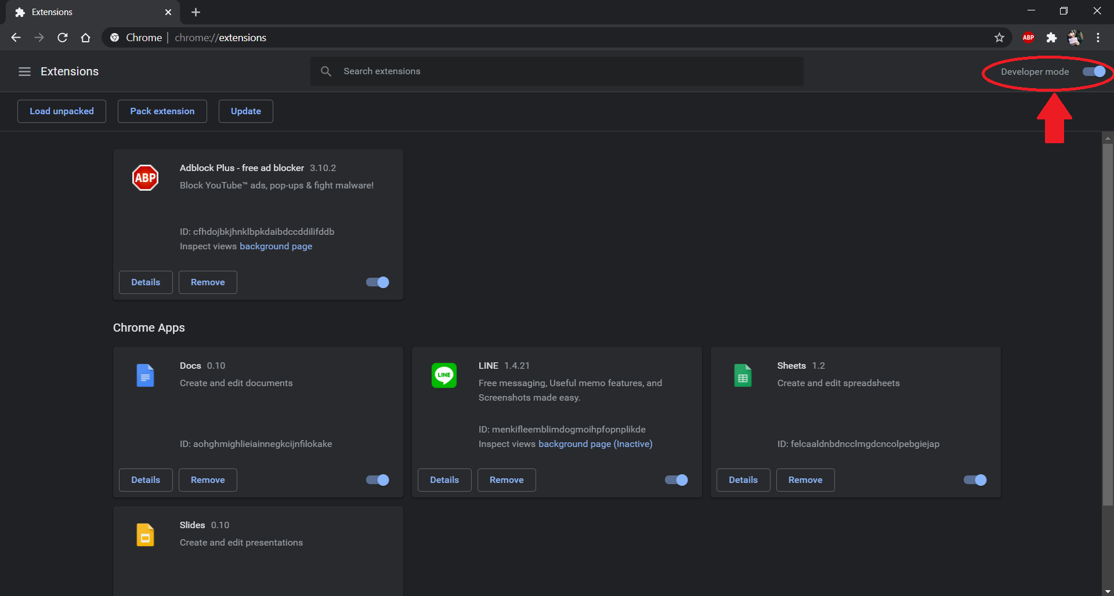

Step 4: Upon enabling Developer mode, click on the “Load Unpacked” button.

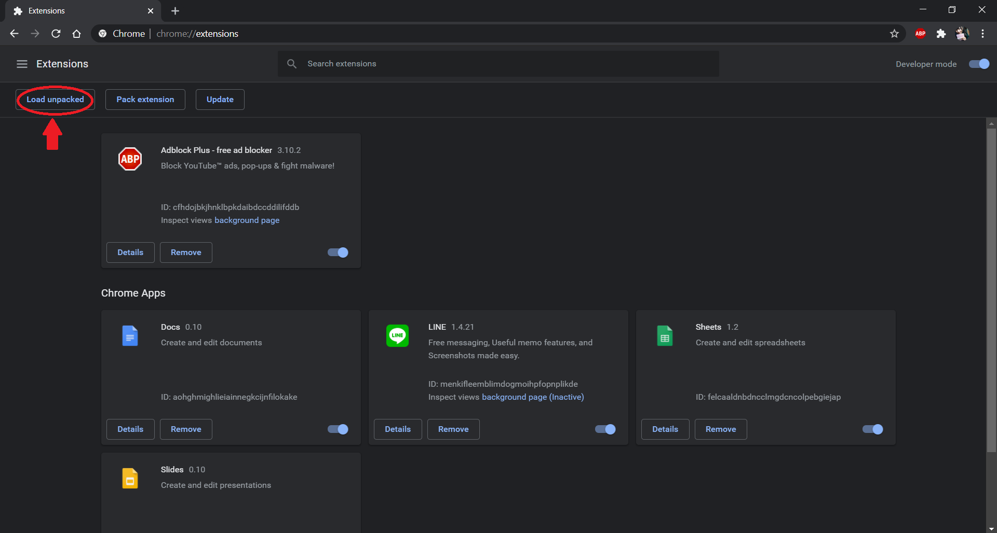

Step 5: Select the extracted folder from the directory that it was extracted to previously.

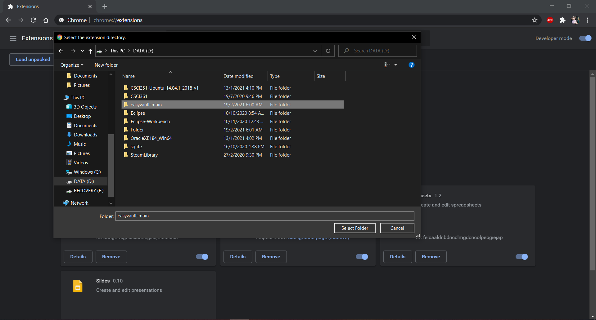

Step 6: Upon clicking on the “Select Folder”, the extension should appear as an installed extension in the Extensions page.

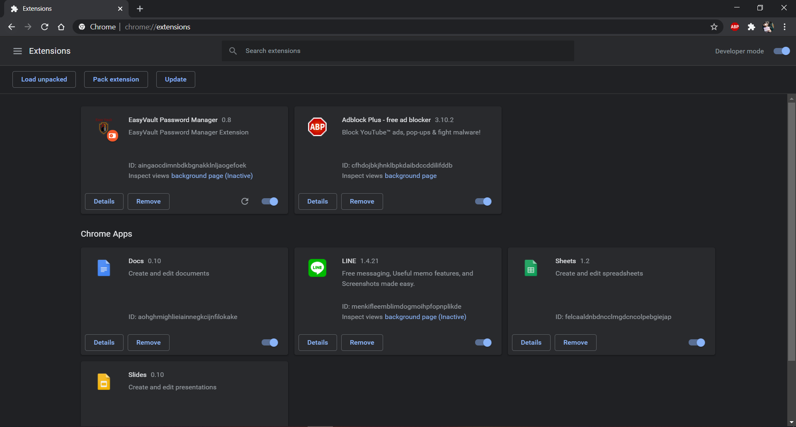

Step 7: Click on the “Extensions” logo on the top right, and click on the “Pin” button to pin the EasyVault extension on the Extension toolbar.

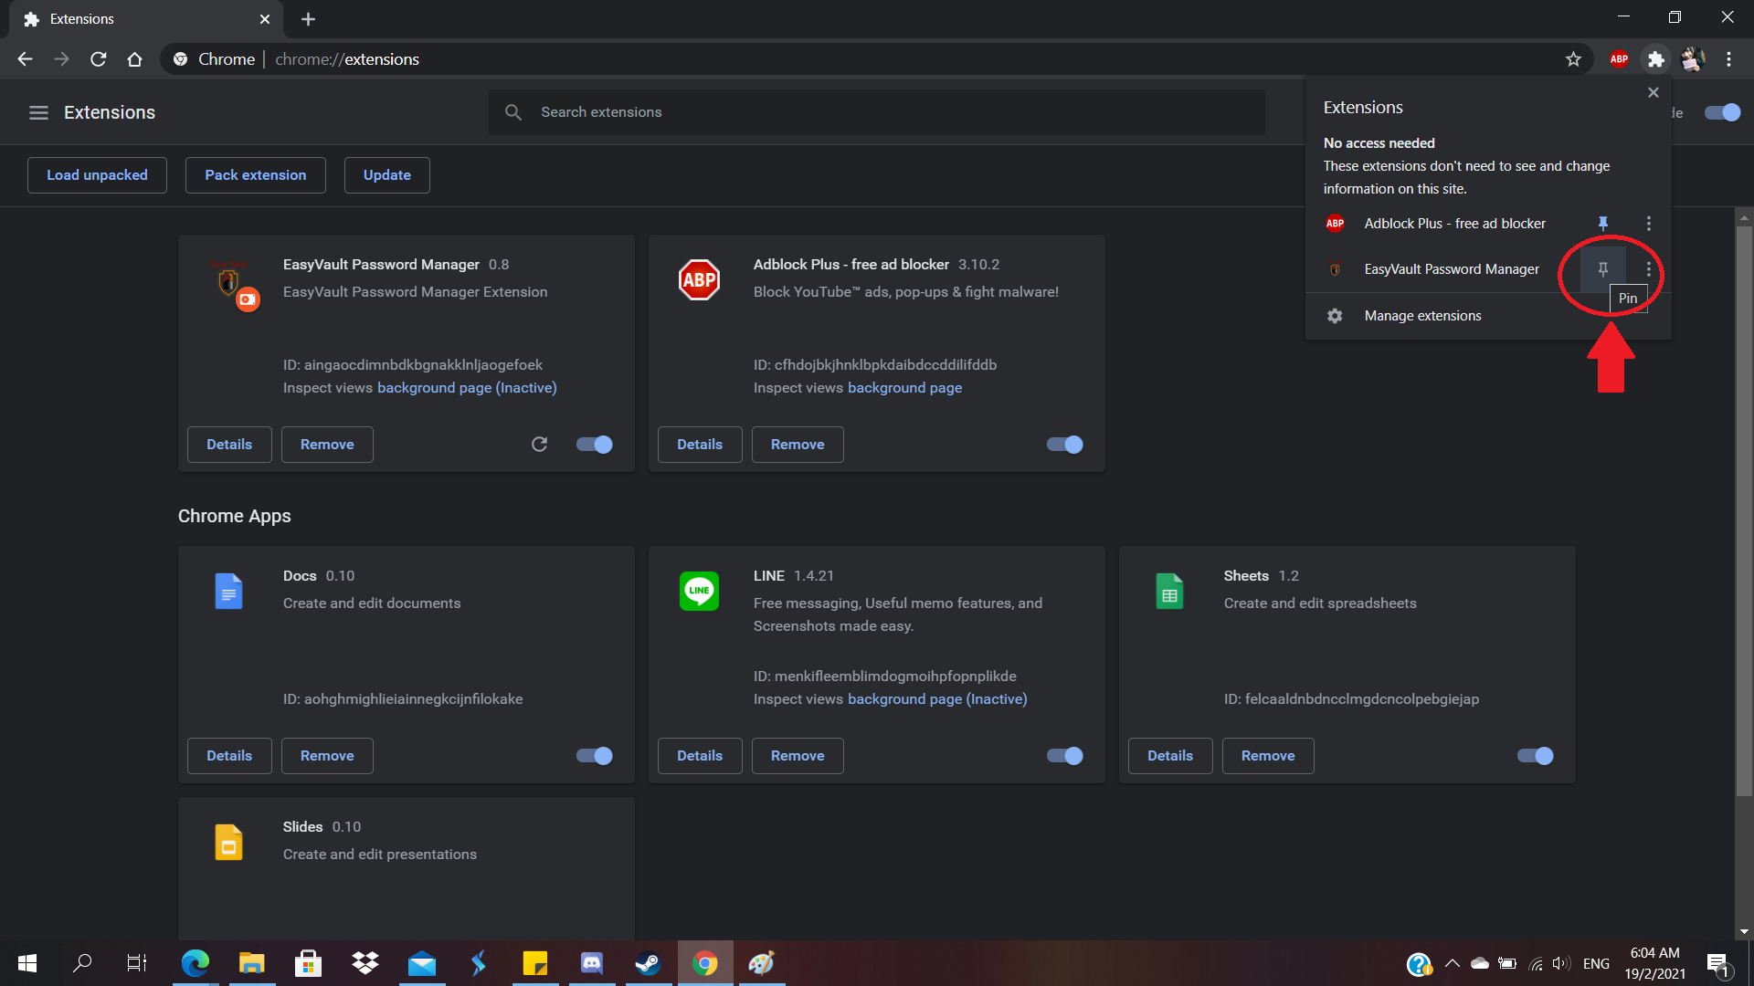

## Microsoft Edge Users

Step 3: Proceed to edge://extensions on your Microsoft Edge Browser and enable the Developer mode.

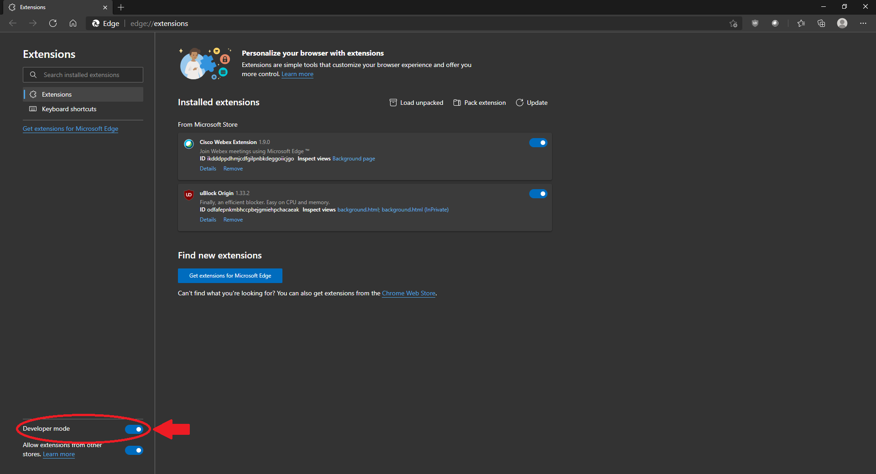

Step 4: Upon enabling Developer mode, click on the “Load Unpacked” button.

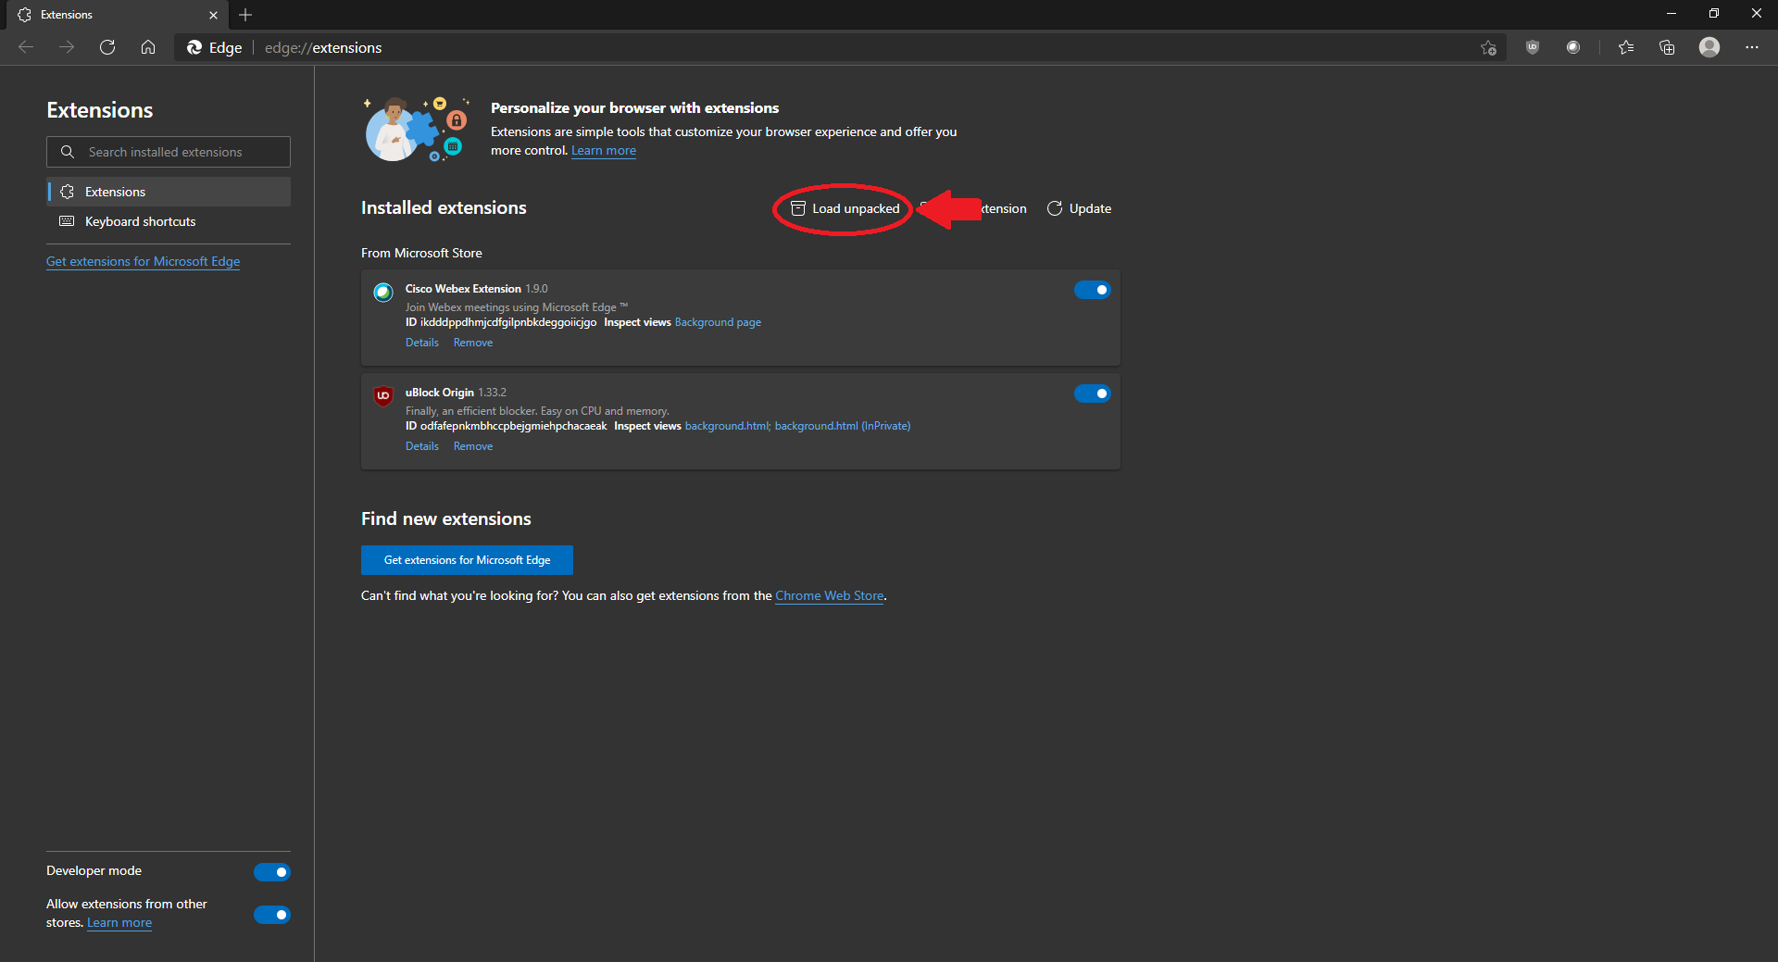

Step 5: Select the extracted folder from the directory that it was extracted to previously.

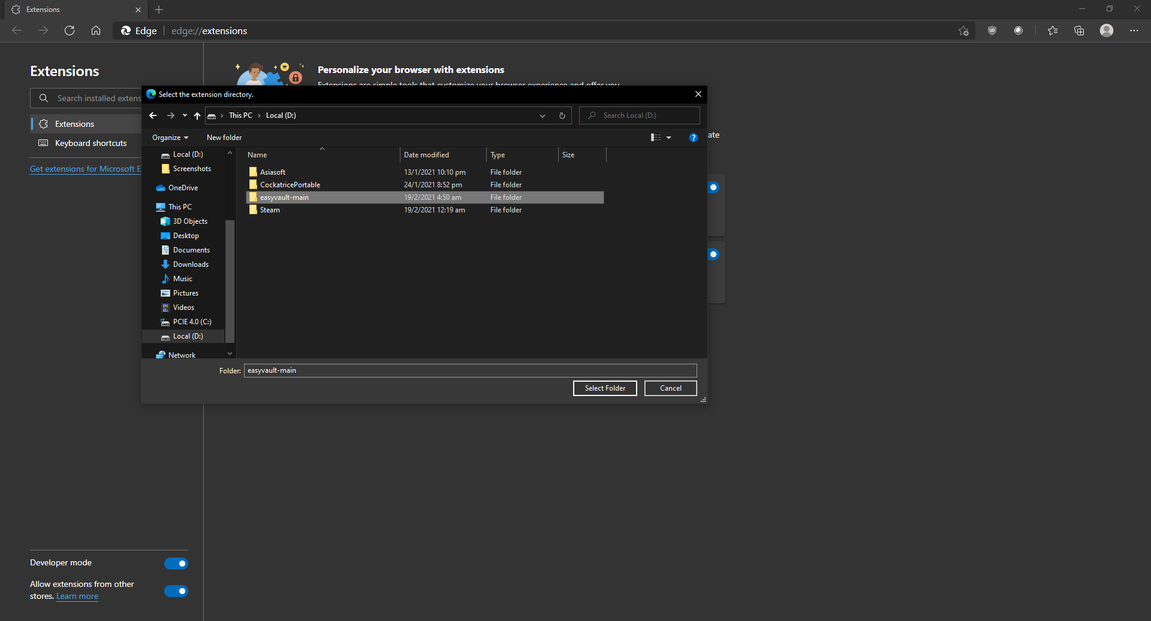

Step 6: Upon clicking on the “Select Folder”, the extension should appear as an installed extension in the Extensions page, as well as having its icon appear.

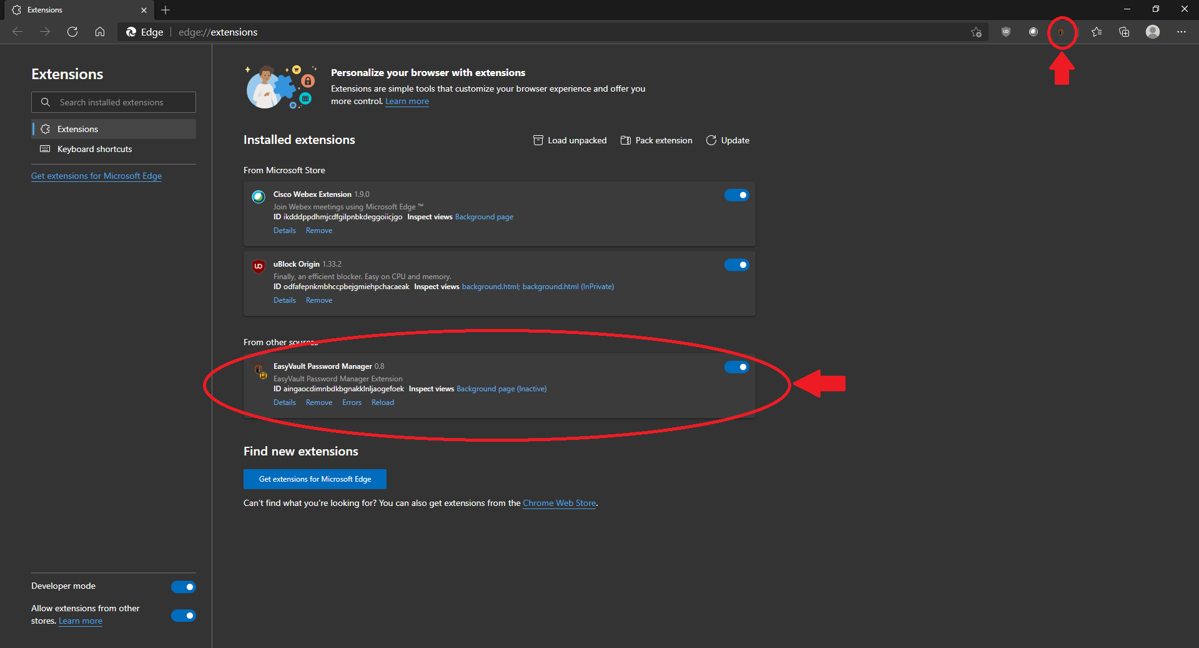

# Setup

Step 1: Proceed to <https://3.20.221.122/api/signup.php> and click on the “Advanced” button.

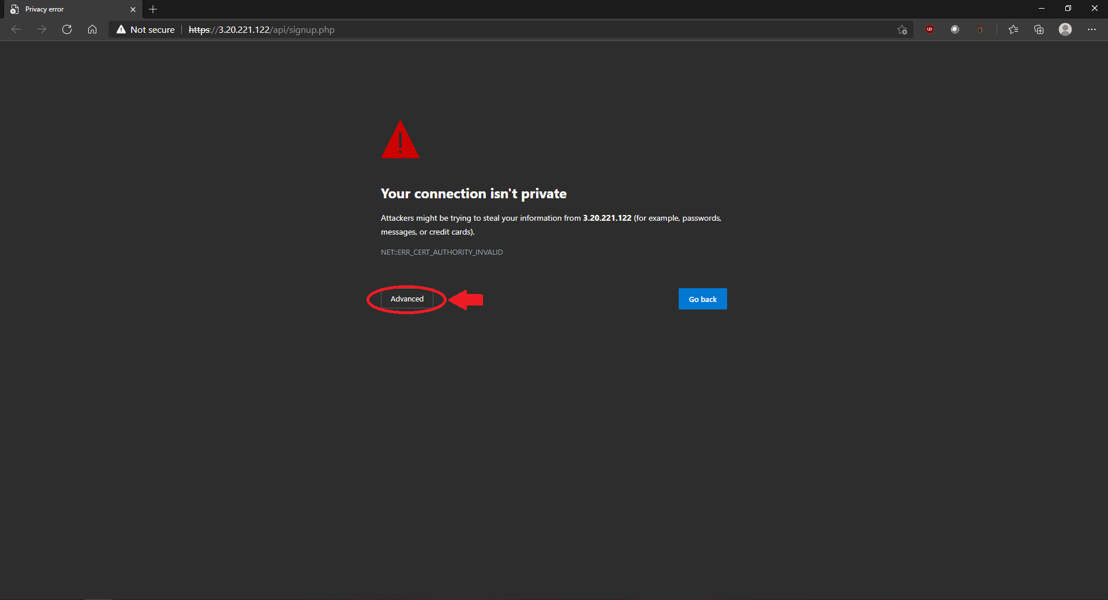

Step 2: Next, click on “Continue to 3.20.221.122 (unsafe)”. Upon being redirected to the address, the user may close the window.

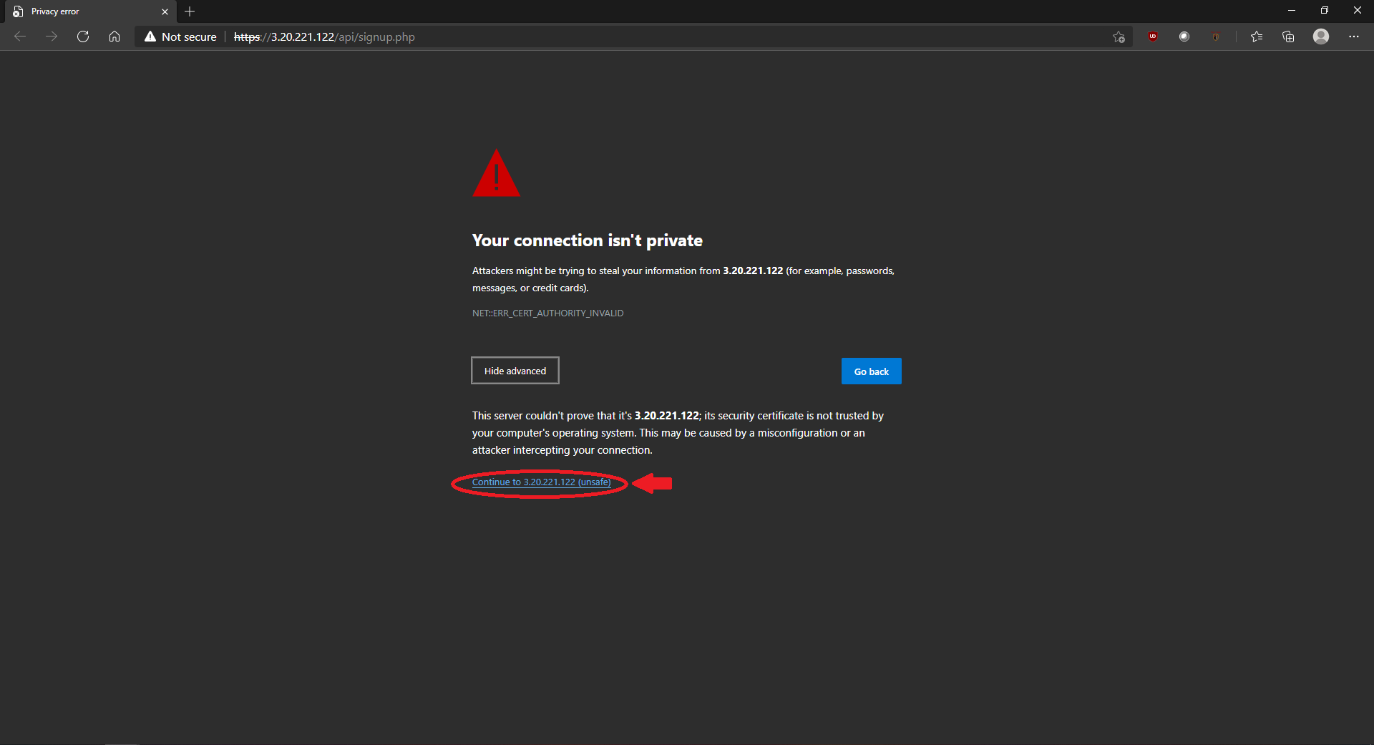

# Registration

Step 1: Click on the “Sign up” button at the bottom right of the Login Page.

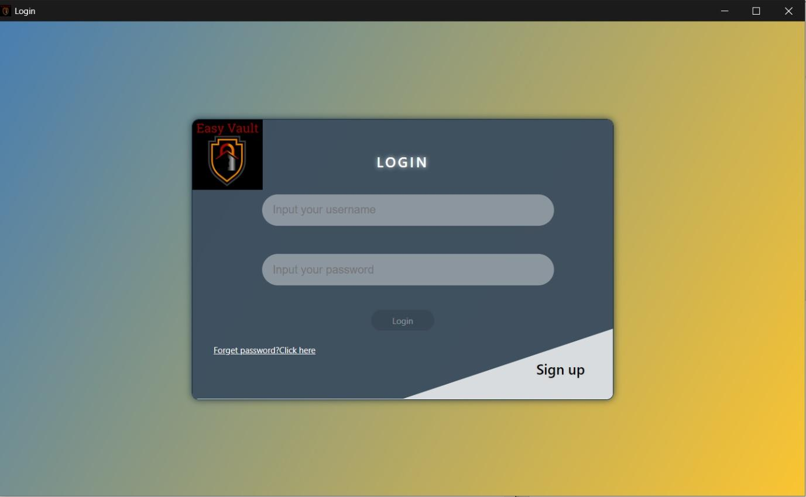

Step 2: Input valid email address into the Username field and input preferred password into the Password and Confirm Password fields and click on the “Sign up” button.

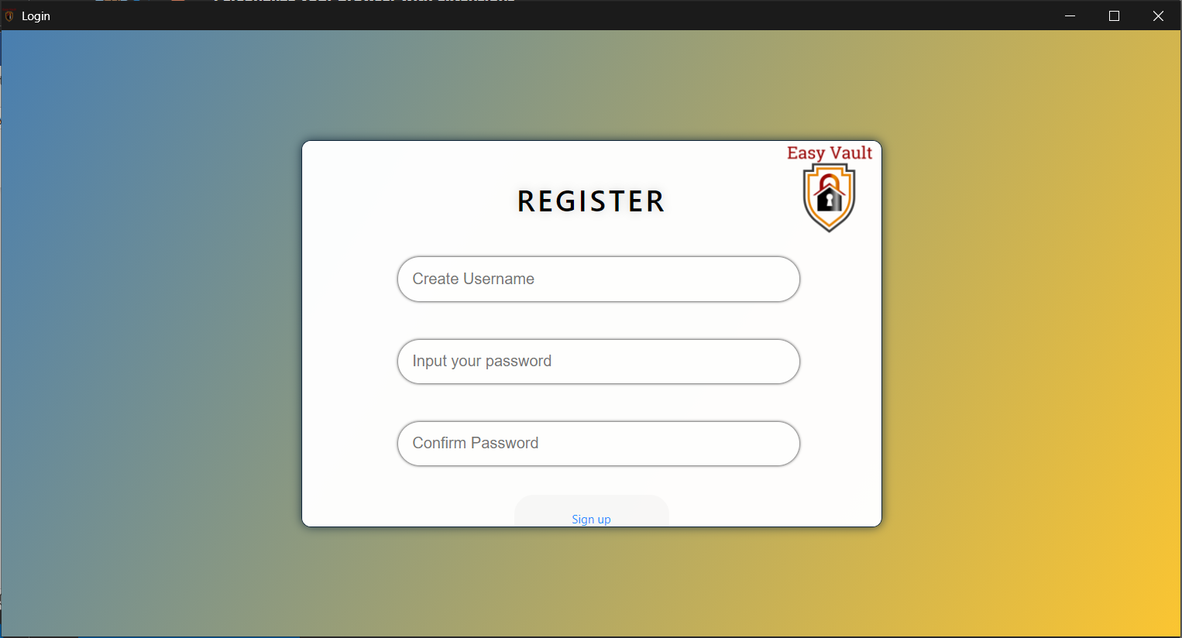

Step 3: Upon successful registration, a prompt will be shown to inform the user that the user is registered.

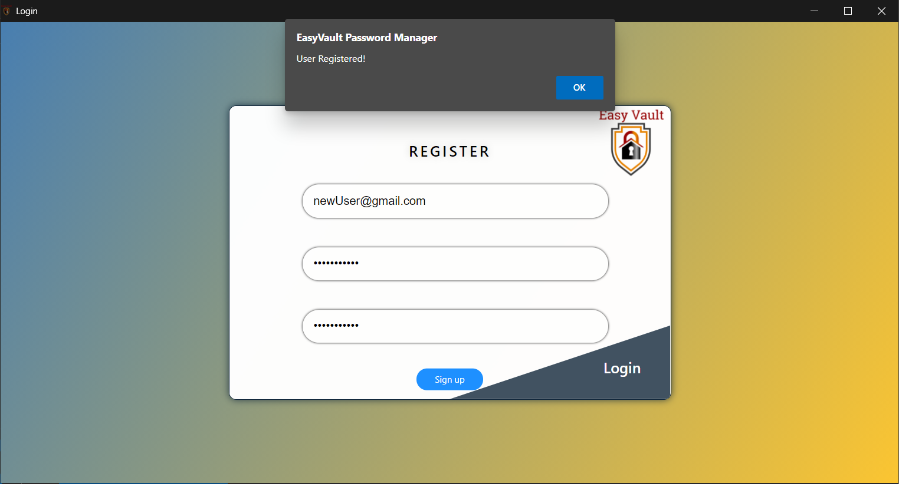

# Login

Step 1: Input registered Email and password into the Username and Password fields and click on the “Login” button.

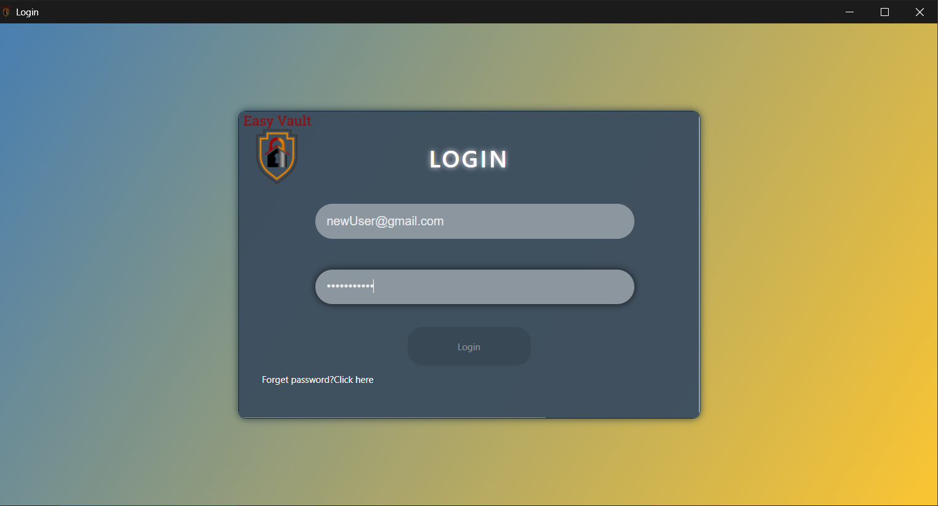

Step 2: An email will be sent to the registered email account, containing the One-time password(OTP). Input the OTP that was in the email, and click on submit.

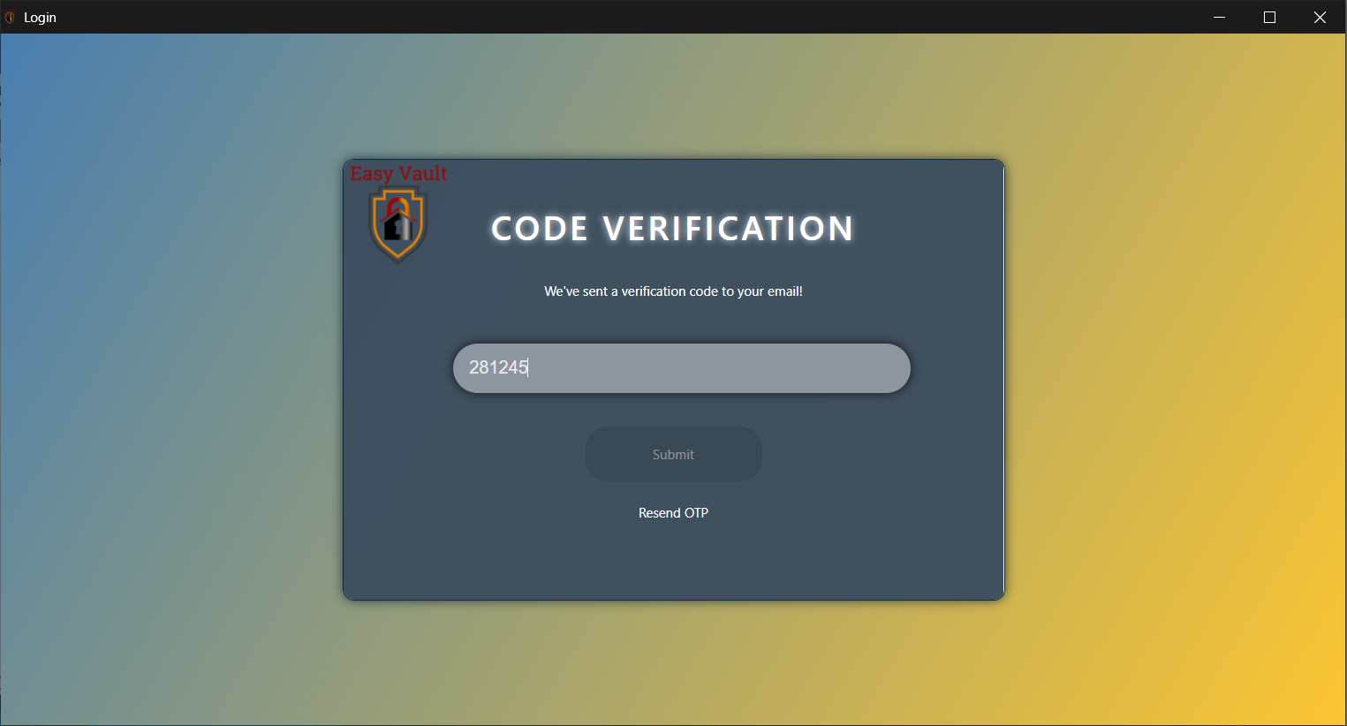

Step 3: Upon successful login, a prompt will be shown to inform the user that the user has logged in successfully and will be redirected to the homepage.

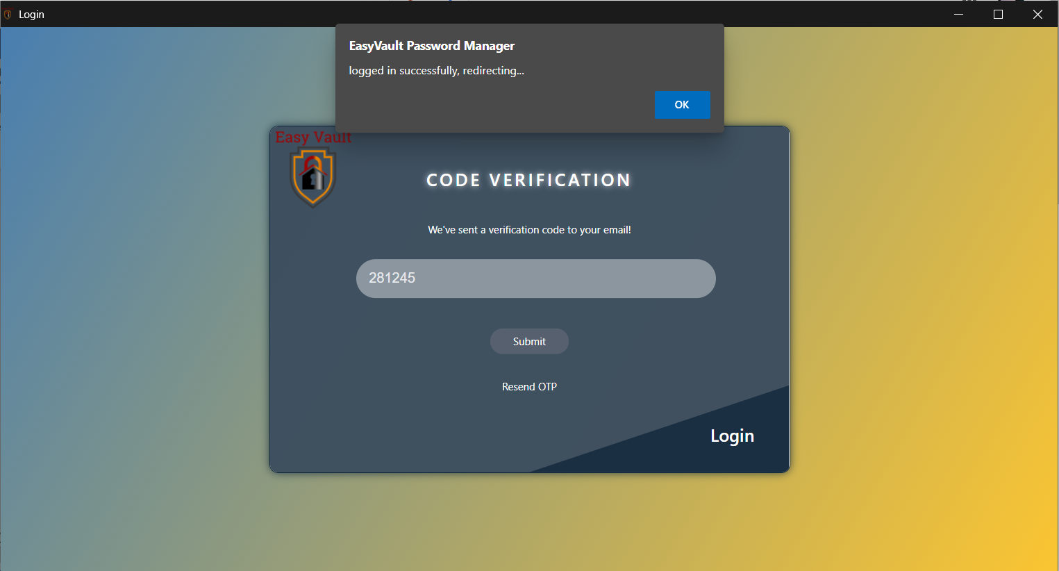

Step 4: User is redirected to the Homepage upon clicking the “ok” button from the login successful prompt.

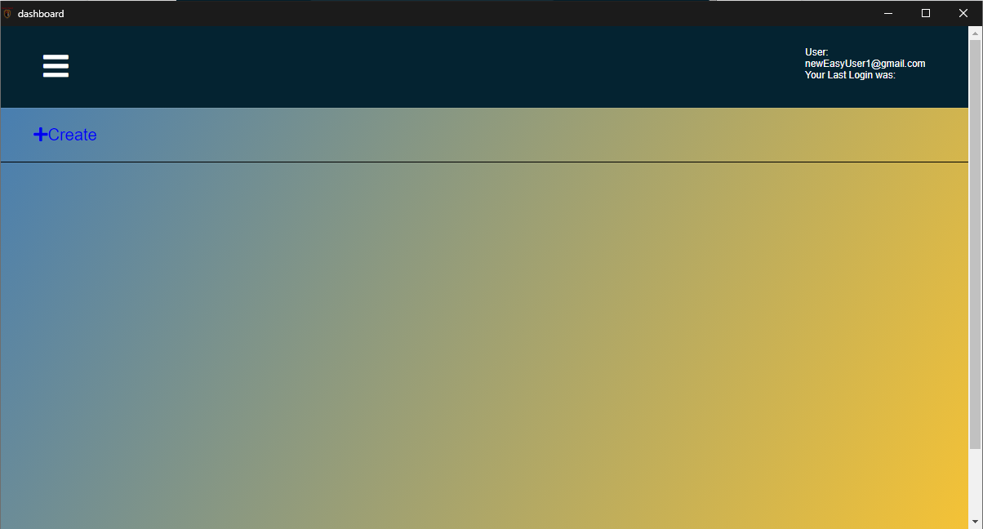

# Resend OTP

Step 1: User to click on the “Resend OTP” button below the “Submit” button.

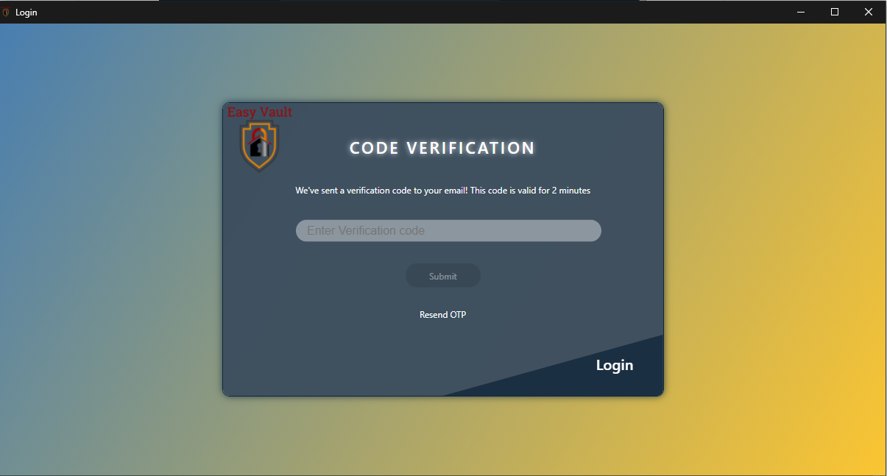

Step 2: A prompt will be shown to inform the user that a OTP has been sent to their email account.

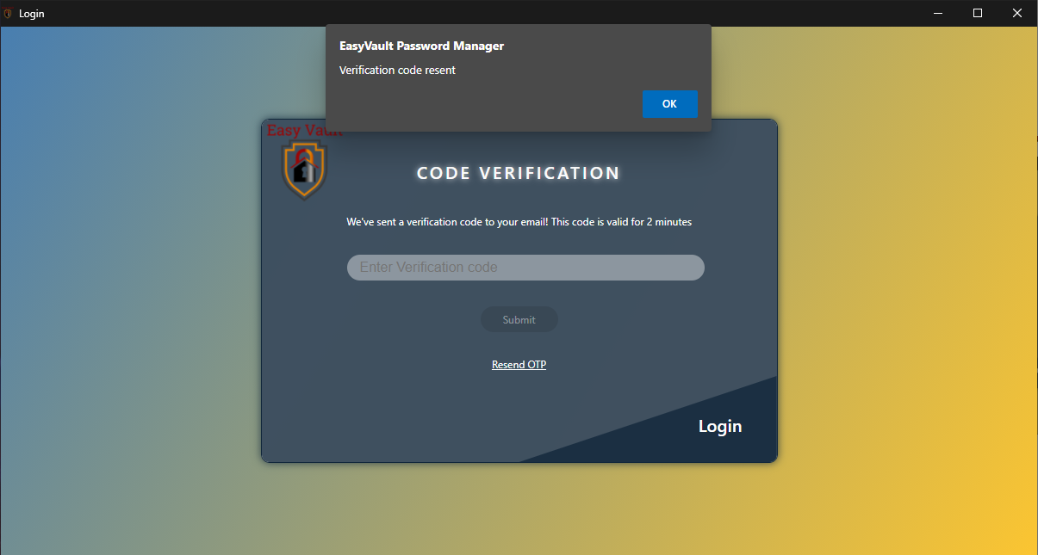

# Forget Password

Step 1: Click on the “Forgot Password?” button at the bottom left of the login page.

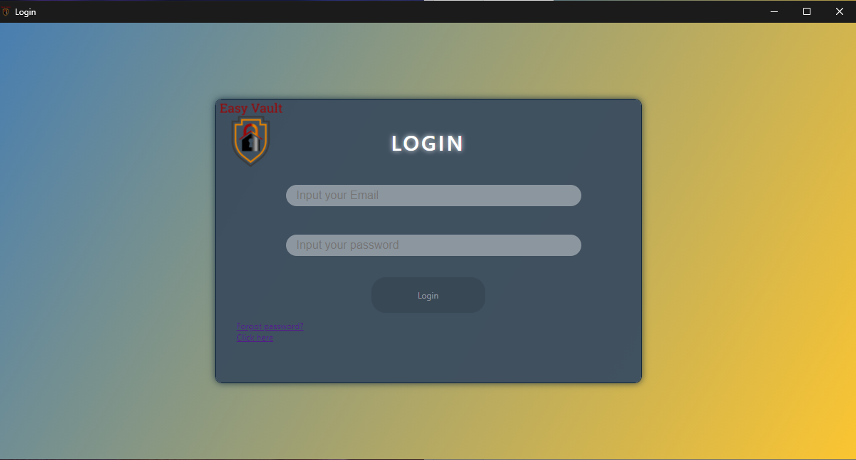

Step 2: User to enter their registered email account and click on the “Continue” button.

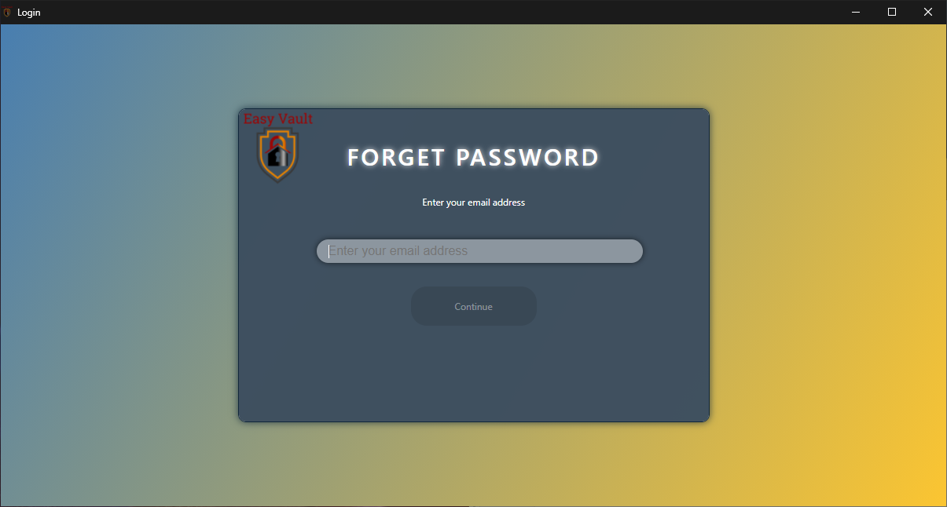

Step 3: User will be directed to a confirmation page, to inform the user that a newly generated password has been sent to their email account.

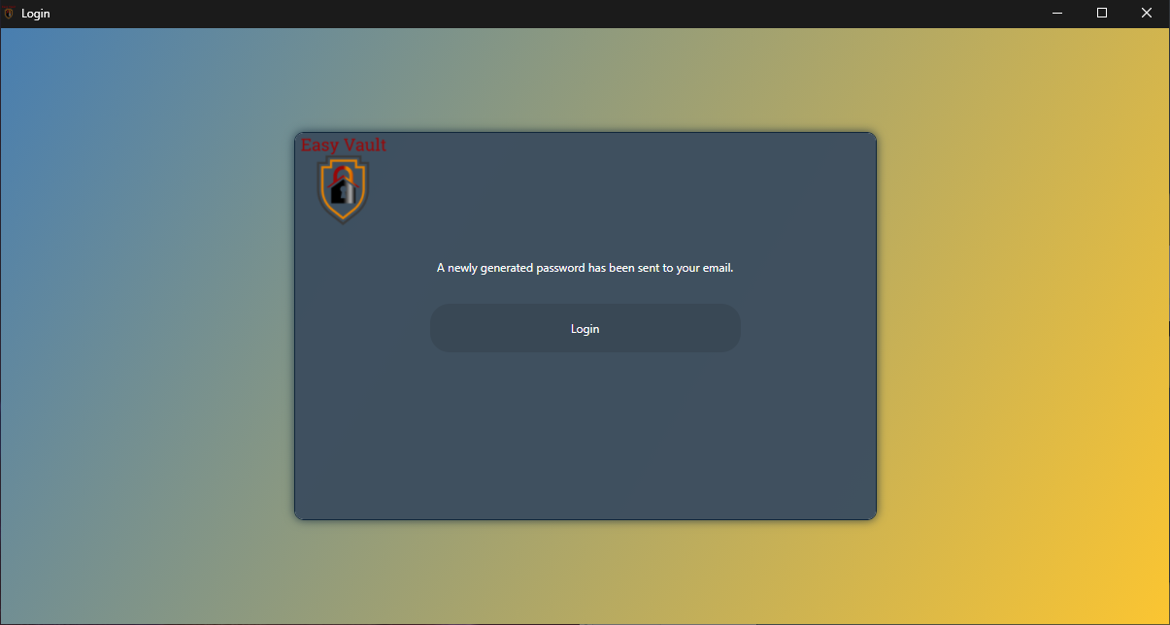

# Adding Password via Application

Step 1: Click on the “Create” button on the top left corner of the Homepage.



Step 2: “Create Password” form will be shown. Enter the URL of the website that the credentials are for in the URL field, the Username of the account used at the website in the Username field, Password used in the password field, and notes relating to the Password being saved in the Notes field if there are any. Upon filling up the necessary details, click on the “Submit” button.

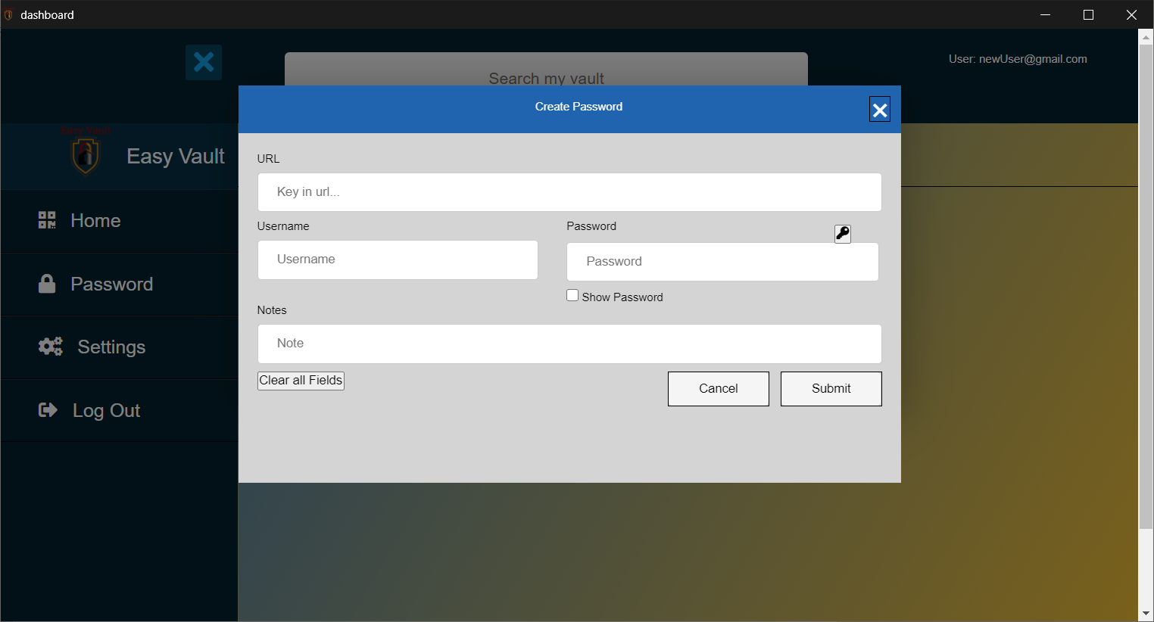

Step 3: A prompt will be shown to inform the user that a new password has been added successfully and will be redirected to the homepage.

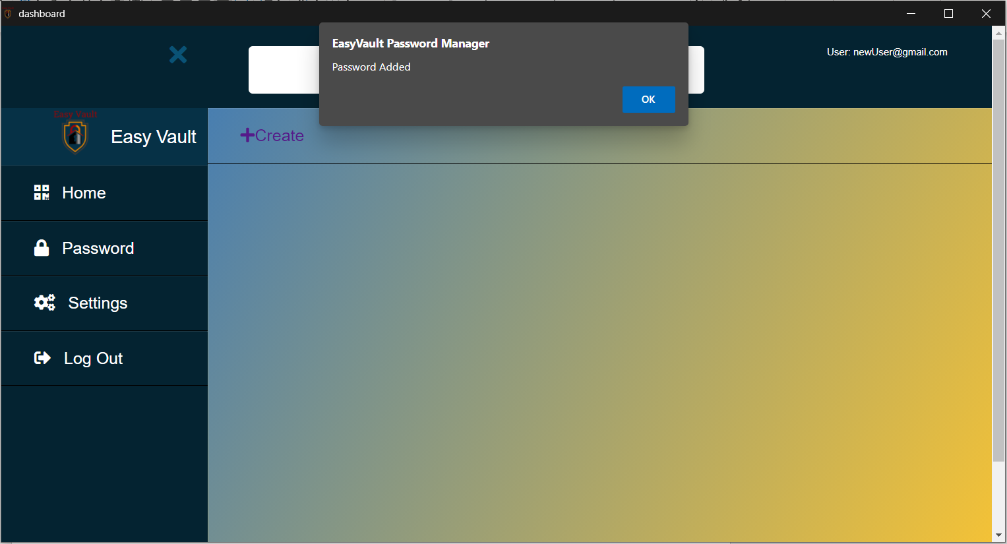

# Editing Password via Application

Step 1: Click on the “Edit” button beside the password to edit the details

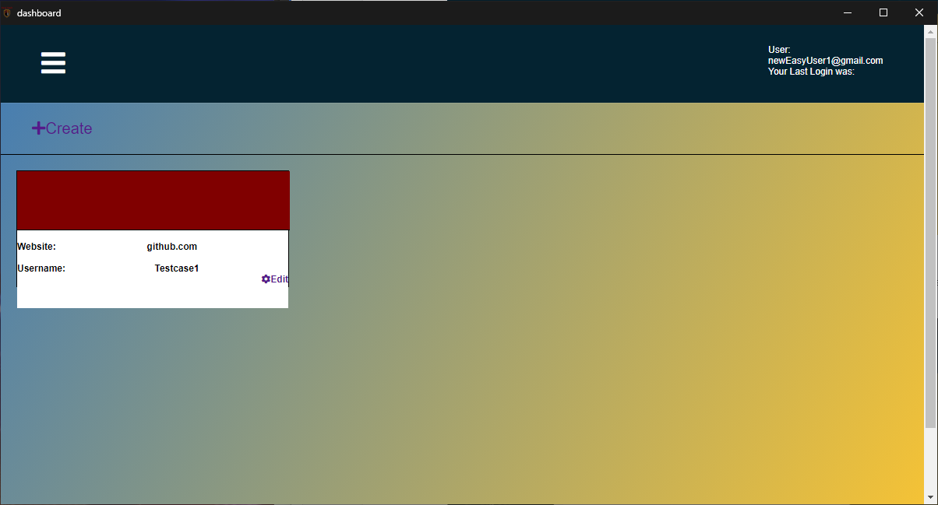

Step 2: “Edit Password” form will be shown. Users can make changes to the fields to edit the details of the saved password, followed by clicking on the “Submit” button to save the changes made.

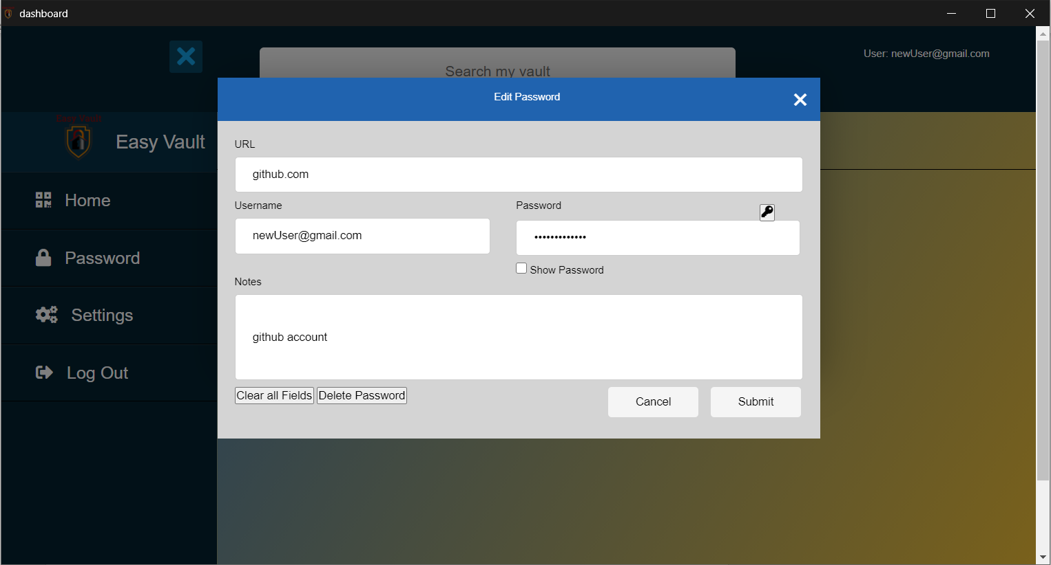

Step 3: A prompt will be shown to inform users that the changes made to the password has been saved and will be redirected to the homepage.

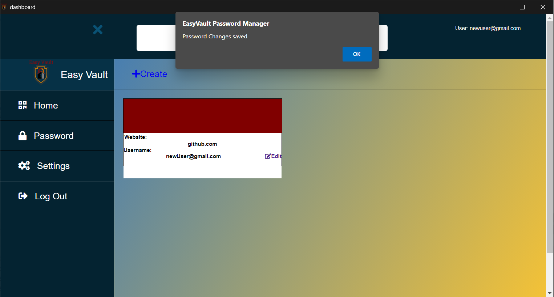

# Deleting Password via Application

Step 1: Click on the “Edit” button beside the password.



Step 2: “Edit Password” form will be shown. Users can click on the “Delete Password” Button to delete the saved password.



Step 3: A prompt will be shown to inform the user that the password has been deleted and will be redirected to the homepage.

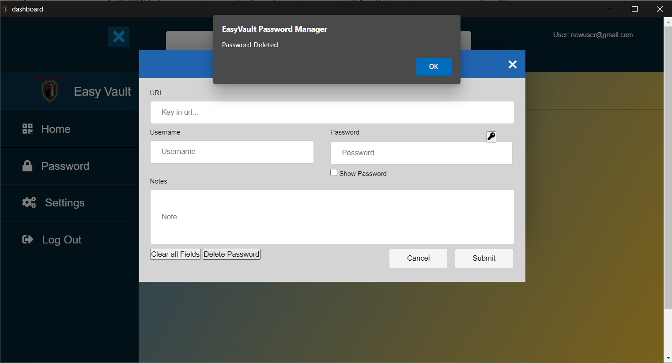

# Password Generation

Step 1: Password Generation can be done by clicking on the “key” icon in the “Create Password” and “Edit Password” forms, as well as the “Settings” page when changing the Master Password.

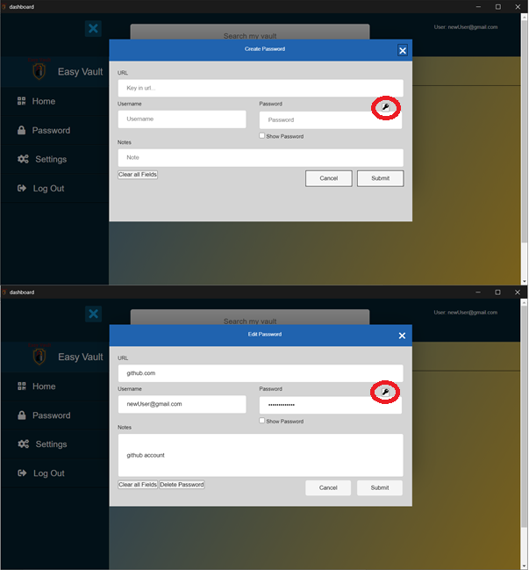 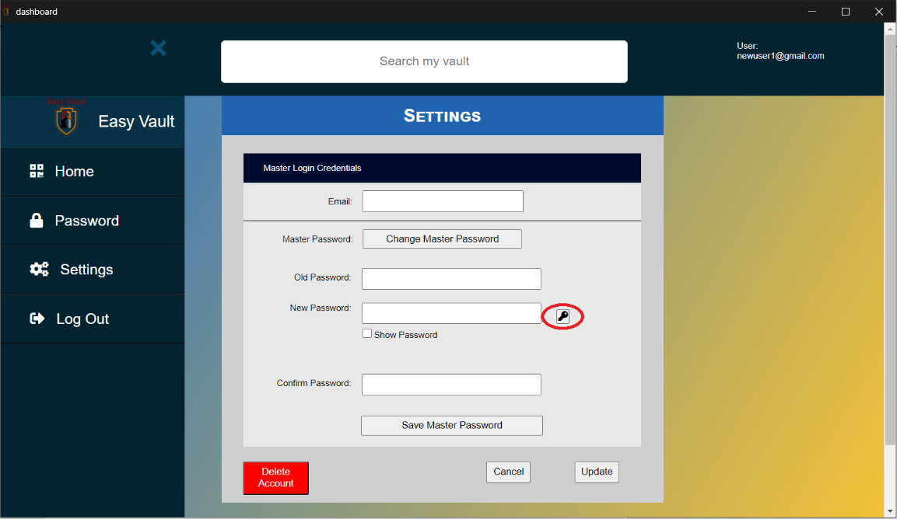

Step 2: The “Generate Secure Password” page will be shown, where the user can set the length of the generated password, as well as choose to exclude the “@” symbol from the generated password. Upon deciding on the length and whether to exclude the “@” symbol, the password will be generated by clicking on the “Generate” button.

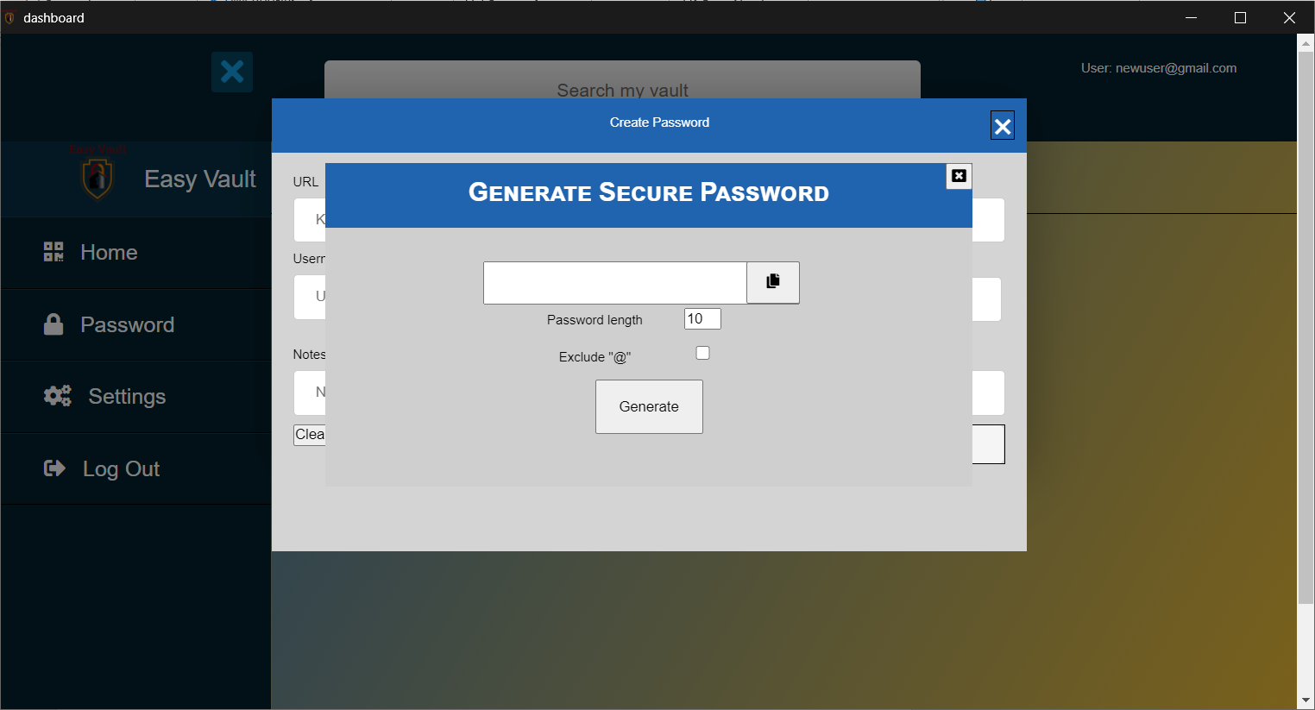

Step 3: The generated password can then be copied by clicking on the “clipboard” icon.

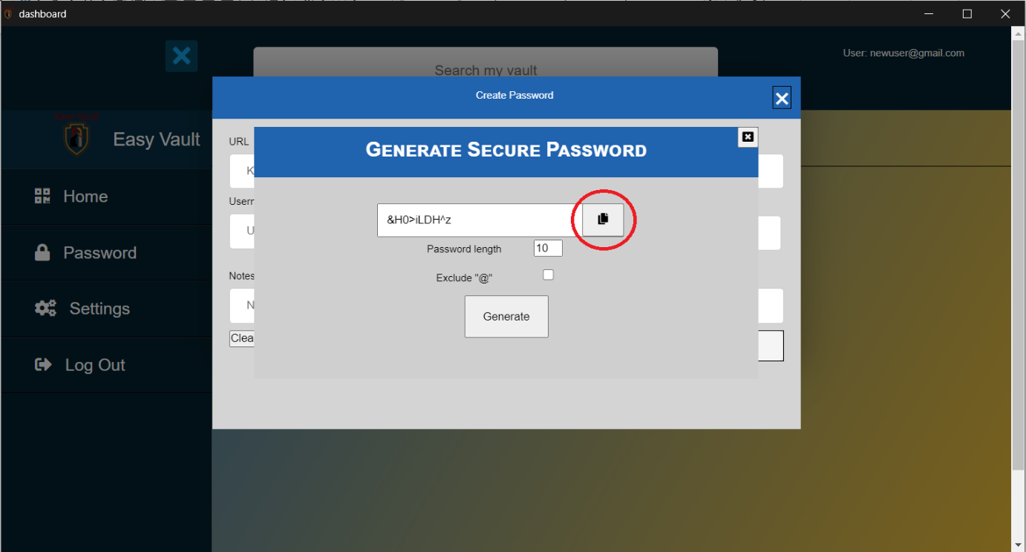

# Password Autofill

Step 1: Upon being logged in to Easy Vault, access any external website of users choice. E.g. github.com. Users can then right click on the Username field, and Select the username for the specific website under the “Easy Vault Usernames” option.

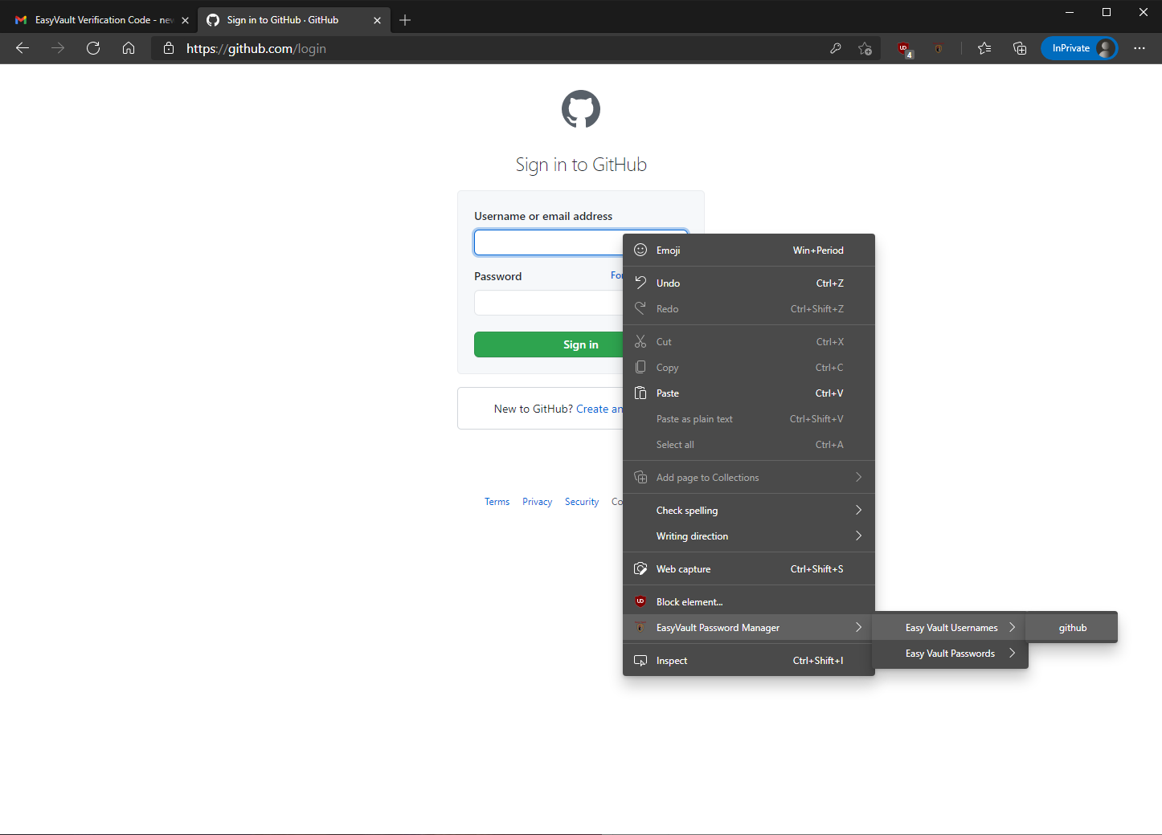

Step 2: The selected username will be autofilled into the Username field by Easy Vault.

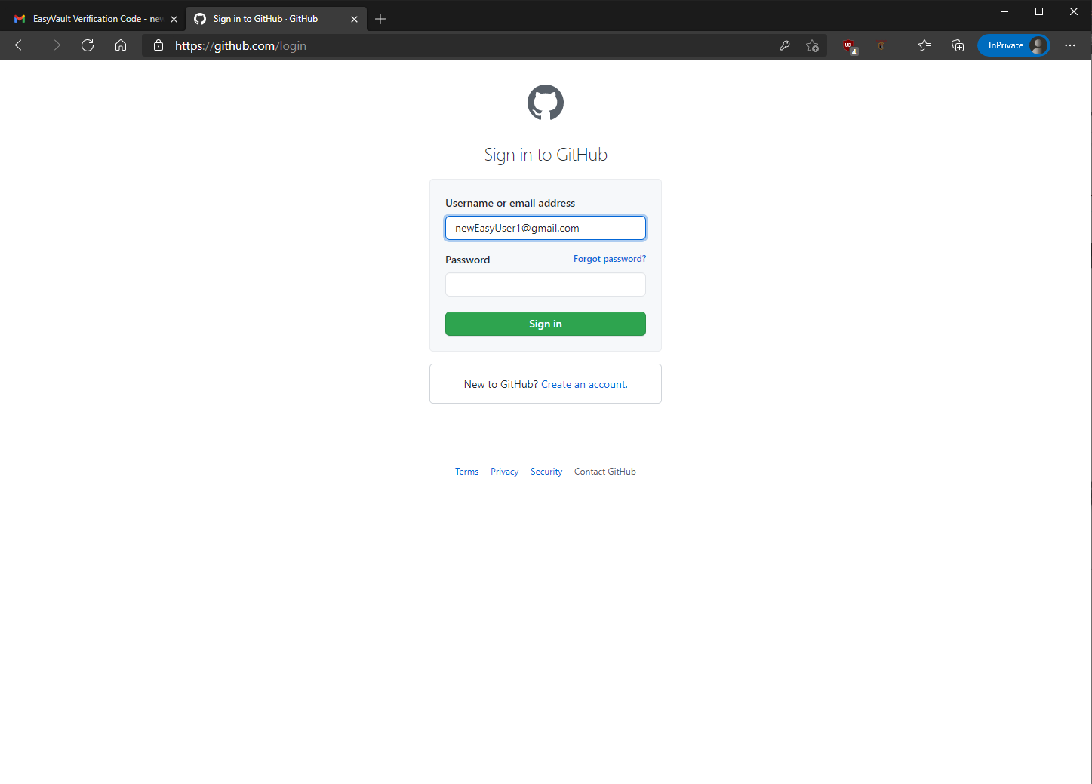

Step 3: Next, users can then right click on the password field, and Select the password for the specific website under the “Easy Vault Passwords” option.

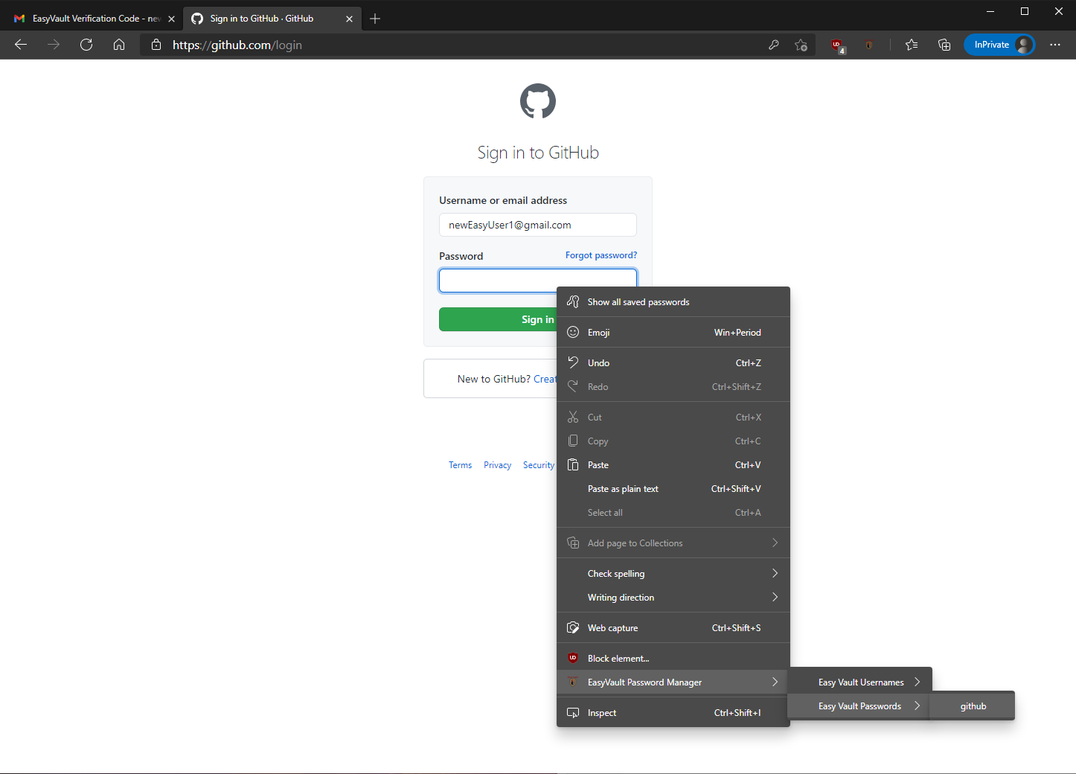

Step 4: The selected username will be autofilled into the Username field by Easy Vault.

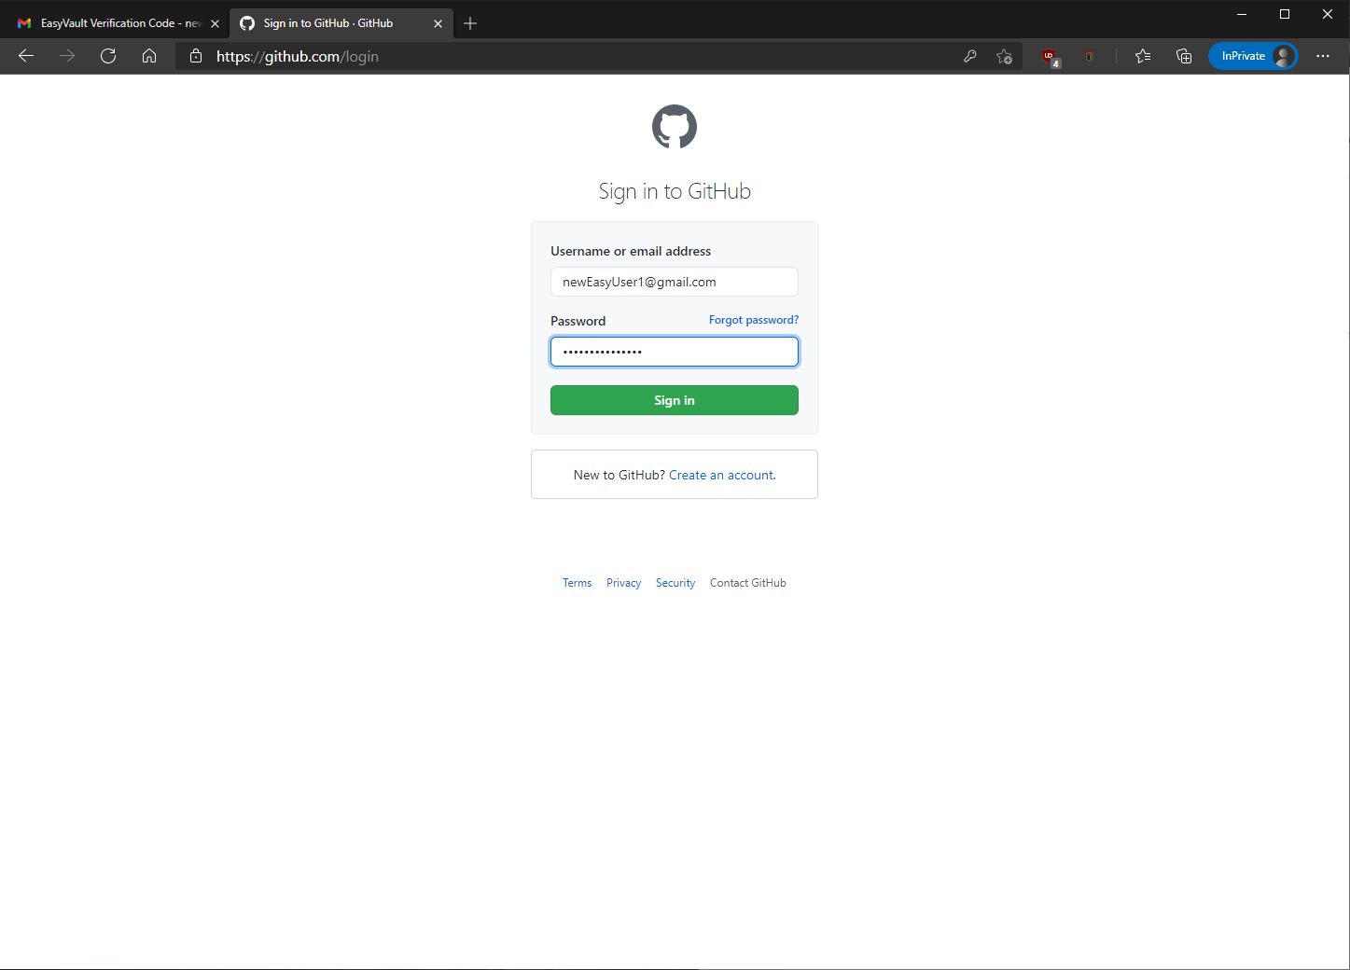

# Changing of Easy Vault Username

Step 1: Click on the “Menu” button on the top left corner of the Homepage.

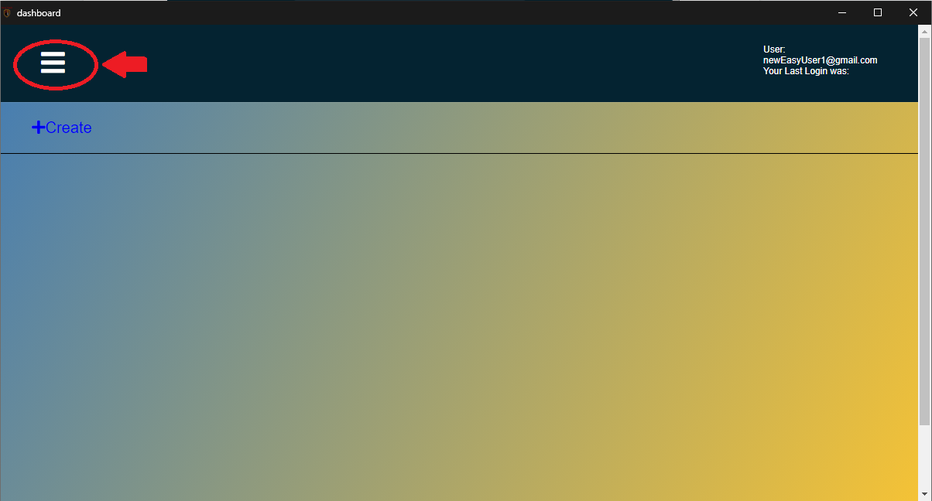

Step 2: Click on “Setting” from the menu to access the “Settings” page, whereby users can change their Username by clicking on the “Change” button beside their current email.

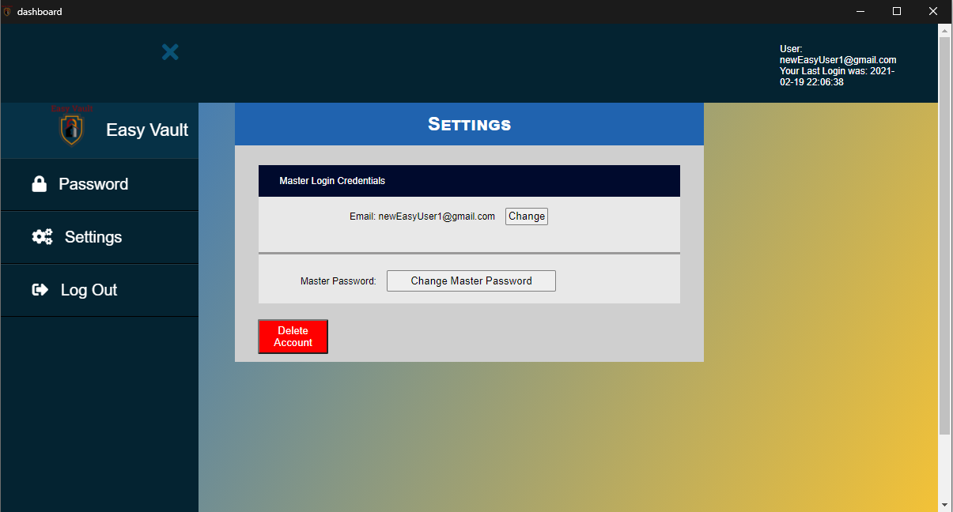

Step 3: Users will be required to input the new Email they would like to use for their Easy Vault account, and input the email again in the Confirm Email field, before clicking on the “Save Email” button.

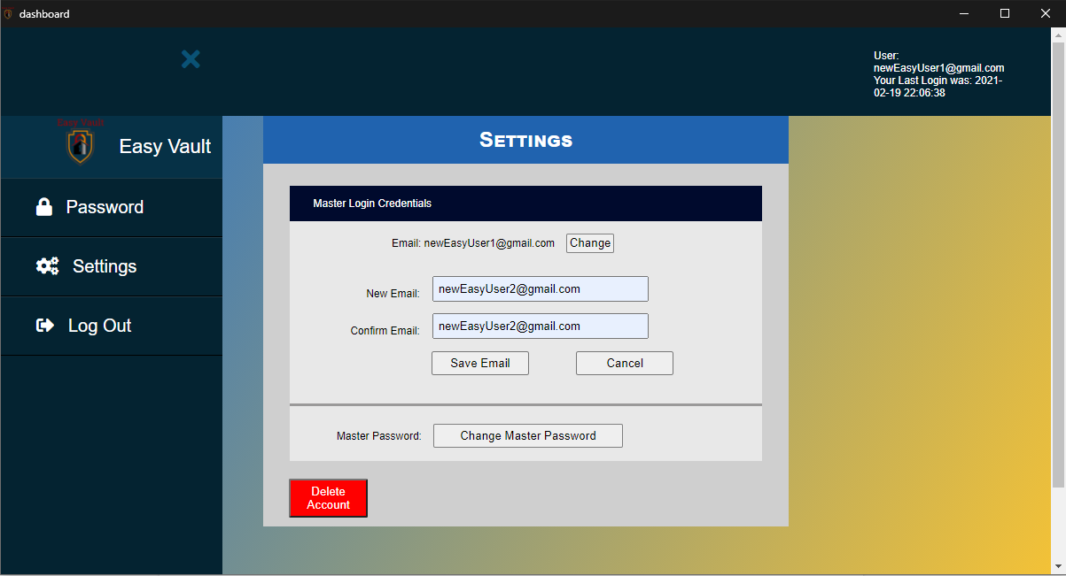

Step 4: A prompt will be shown to inform the user that the email has been changed and will be logged out and redirected to the login page, where they will be required to login with the new email. An email will be sent to the user's new email address, notifying the user that the email account used for Easy Vault has been successfully changed as well.

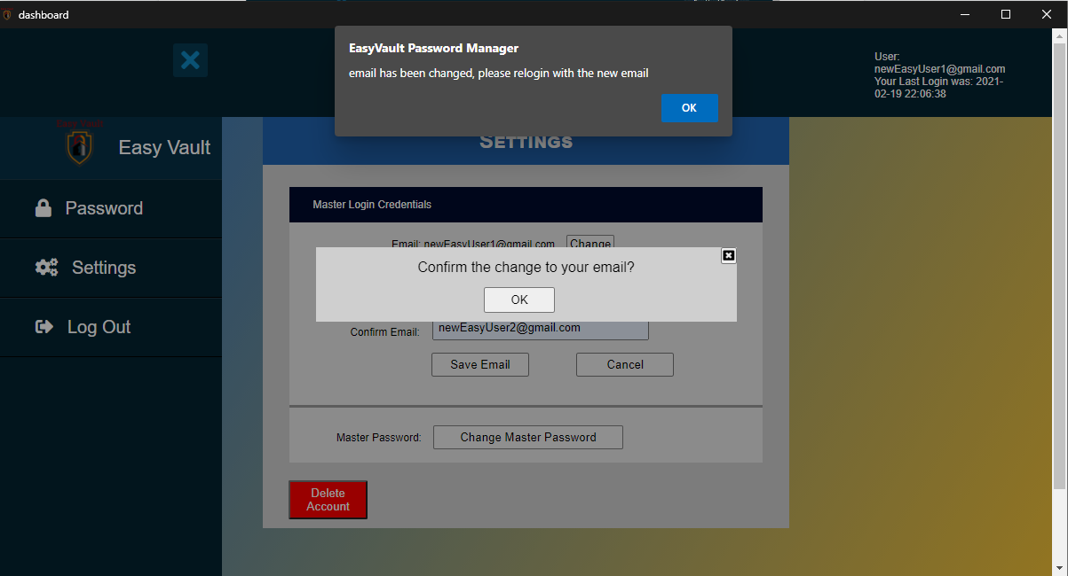

# Changing of Master Password

Step 1: Click on the “Menu” button on the top left corner of the Homepage.



Step 2: Click on “Setting” from the menu to access the “Settings” page, whereby users can click on the “Change Master Password” button to change the Master Password.



Step 3: User will be required to input the current password, as well as the new password into the fields, and click on the “Save Master Password” button.

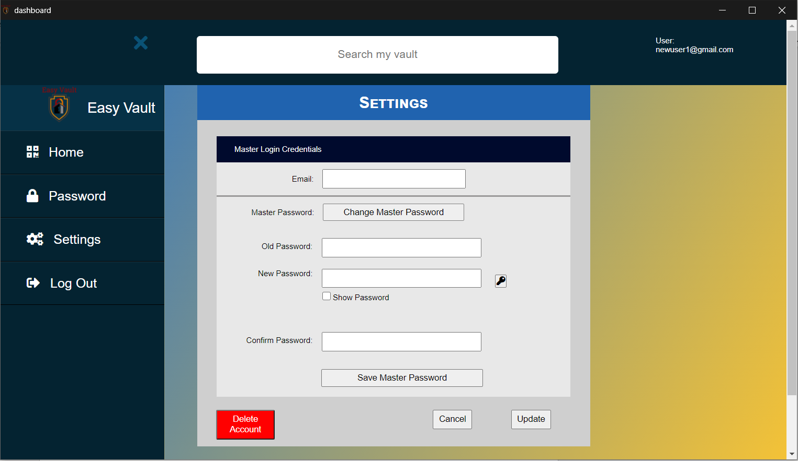

Step 4: A prompt will be shown to inform the user that the Master Password has been changed and will be logged out and redirected to the login page, where they will be required to login with the new Master Password. An email will be sent to the user's email, notifying the user that the Master Password for Easy Vault has been successfully changed as well.

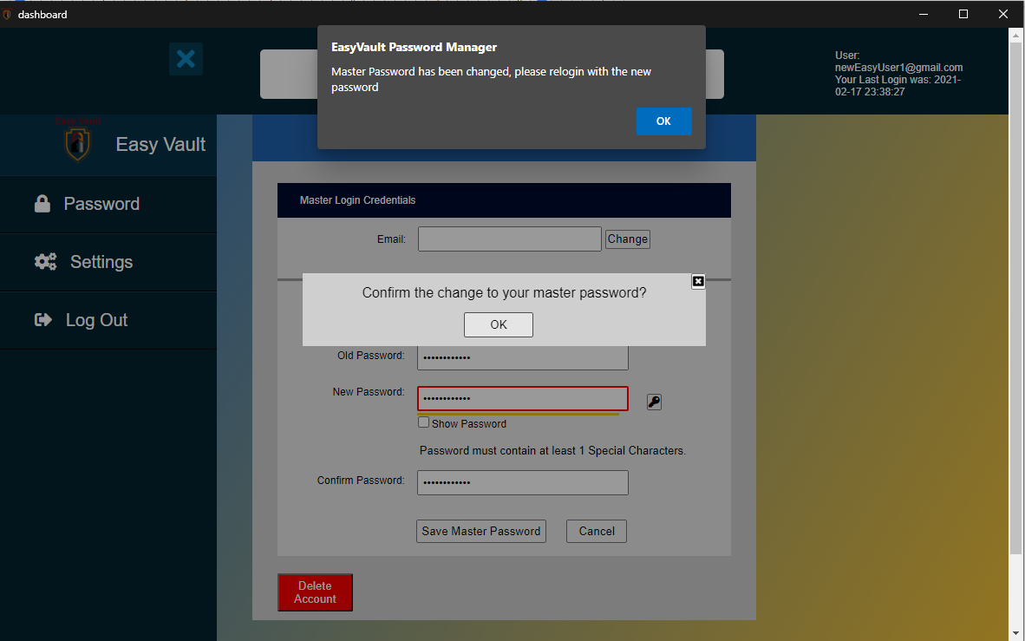

# Deleting Easy Vault Account

Step 1: Click on the “Menu” button on the top left corner of the Homepage.



Step 2: Click on “Setting” from the menu to access the “Settings” page, whereby users can click on the “Delete Account” button to delete their Easy Vault account, as well as all data related to the account.

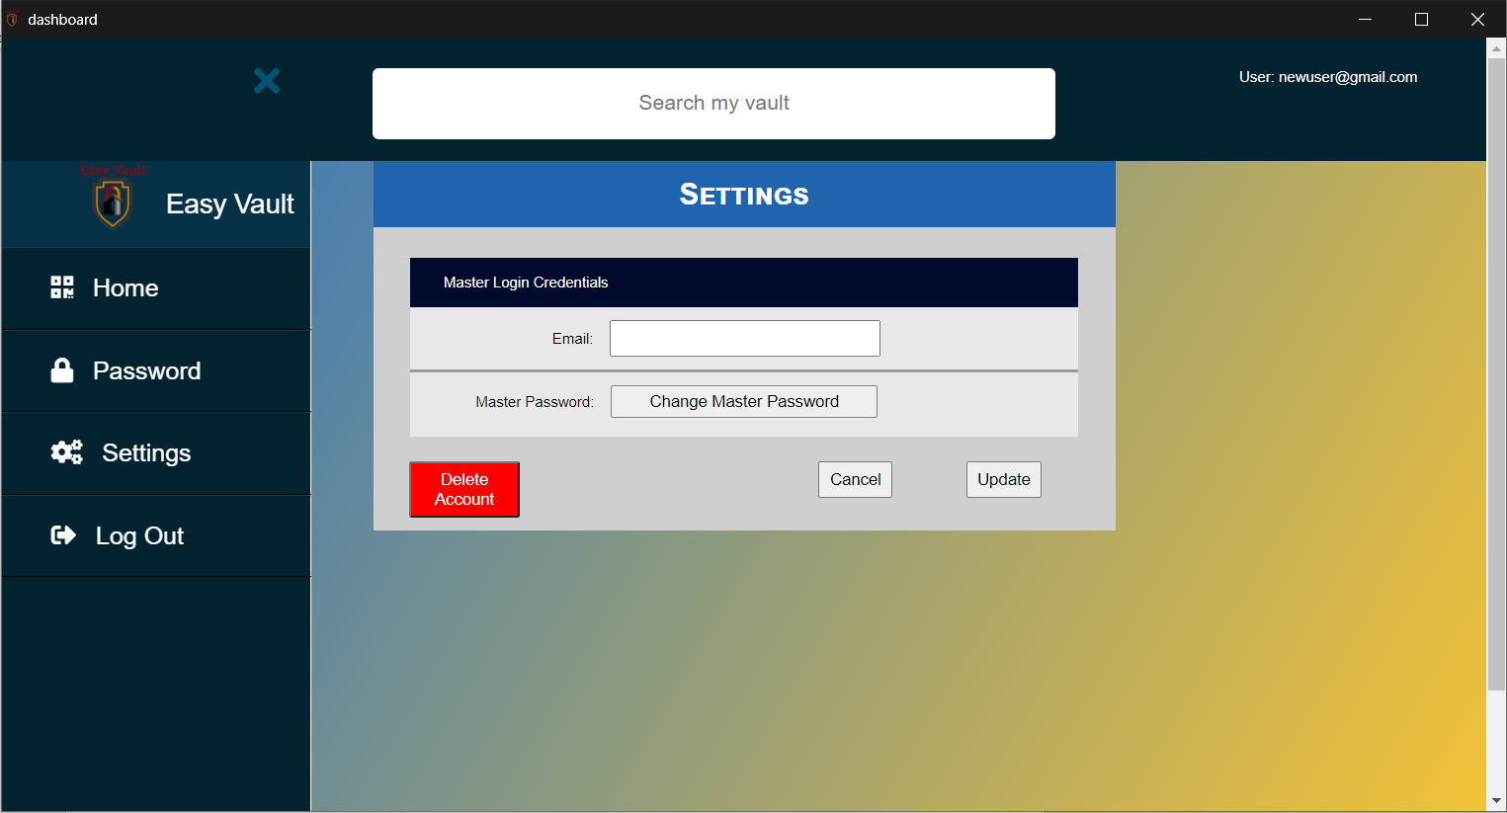

Step 3: Clicking on the “OK” button on the confirmation page will delete the user’s account.

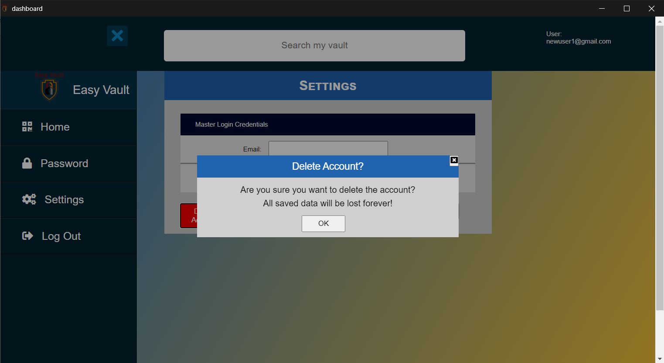

Step 4: A prompt will be shown to inform the user that the account has been successfully deleted. After which, the User will be logged out and be redirected to the login page.

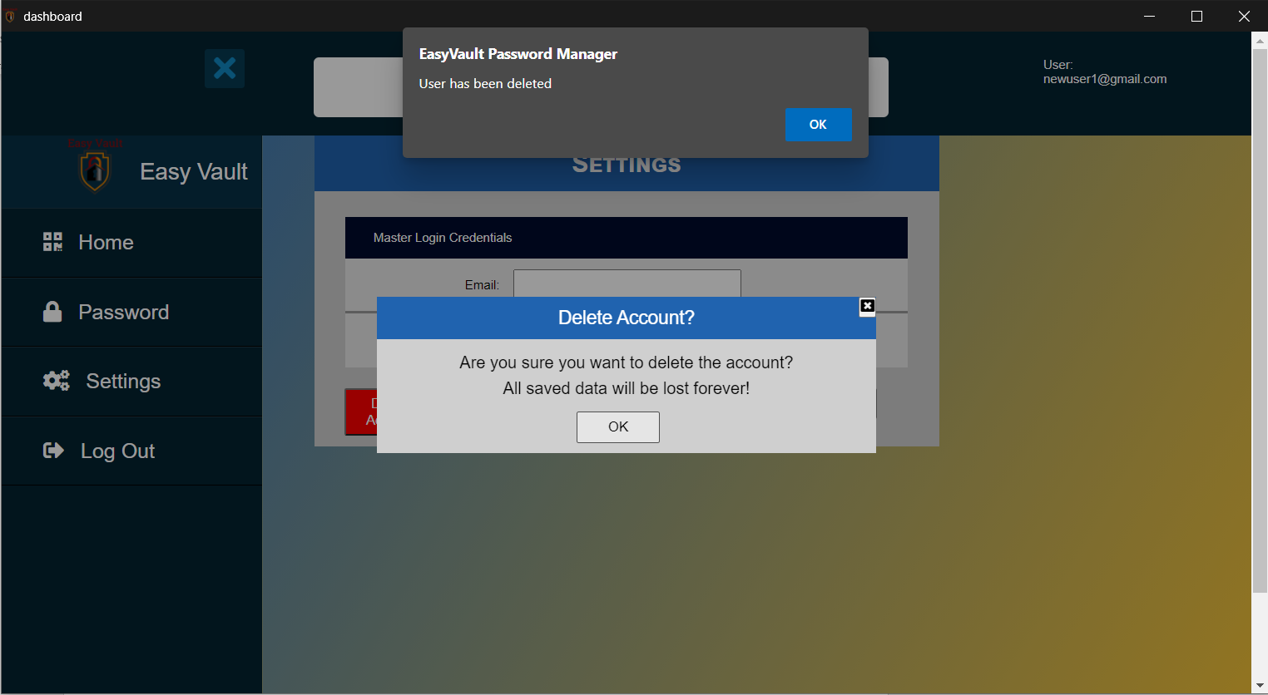

# Logout

Step 1: Click on the “Menu” button on the top left corner of the Homepage.



Step 2: Click on the “Logout” Button to logout.

